**PROJECT REPORT ON**



**Submitted by :**

**Rishabh Kumar (16GG20023)**

**Integrated M.Sc. 4th Year,**

**Department of Geology and Geophysics,**

**IIT Kharagpur**

**Under the Guidance of :**

**Professor Shubhabrata Paul,**

**Department of Geology and Geophysics,**

**IIT Kharagpur**

**CONTENT**

|  |  |  |
| --- | --- | --- |
| **Sl No:** | **Title** | **Page No:** |
| 1) | Acknowledgement | 3 |
| 2) | Introduction | 4-7 |
| 3) | Materials and Methods | 8-9 |
| 4) | Result and Discussion | 10-12 |
| 5) | References | 13-15 |
| 6) | Supplementary Materials | 16-26 |

**Acknowledgement**

On the successful accomplishment of this summer training, I would like to take this opportunity to extend my deepest sense of gratitude and appreciation towards those who extended all support and facilities without which this report would not have seen the daylight. I deem it a proud privilege and feel immense pleasure to acknowledge all those who are directly or indirectly involved. First and foremost, I am grateful to Prof Shubhabrata Paul for having provided me with a chance to work on this Project.

I extend my deepest gratitude to Mrs Debarati Chattopadhyay for her guidance and constant supervision, providing necessary information regarding the Project and for extensive support in completing the Project report.

**Introduction:**

Origination and extinction rate are the key factors that promote diversification of a lineage (Valentine,1969; Sepkoski, 1981, 1984, 1996; Benton1995; Hunter, 1998). Both biotic and abiotic factors may have a major influence on origination and extinction rates (Benton, 2009; Ezard et al, 2011; Lehtonen et al, 2017). Many authors have highlighted the fact that rate of speciation is largely controlled by biotic interactions such as competition and predation (Macarthur, 1969; Rosenzweig, 1975; Walker & Valentine, 1984; Chase et al, 2002). Alroy, (2008) showed, recoveries of diversity after a mass extinction event was mainly facilitated by an increased rate of predation and competition. On the other hand, Roy et al, (2007) showed that the climate has a significant effect on large-scale patterns of species diversity, and various other studies have shown strong correlations between diversity and abiotic factors such as temperature, shelf area and productivity (Currie 1991; Roy et al. 1998; Mittelbach et al. 2001; Hawkins et al. 2003; Currie et al. 2004).

As both the biotic and environmental parameters change with latitude (Gosz, 1992; Soininen, 2010), a gradient in origination and extinction rate can be expected with latitudinal variation. In this context, Latitudinal diversity gradient (LDG)  has been established as one of the strongest patterns of global marine diversity which shows a decrease in the number of species and higher taxa from the equator to the poles, supported by several terrestrial and marine organisms (Hillebrand, 2004; Mittelbach et al, 2007; Tittensor, 2010). This pattern is observed for both recent (Hillebrand, 2004) and fossil records (Leighton,2005; Crame, 2001; Rosenzweig, 1995; Cecca, 2002; Shen & Shi, 2004; Cecca et al, 2005). Nonetheless, a major gap exists for understanding the mechanism of the LDG pattern, especially in marine context (Lewin,1989). The mechanism of climate-induced variability in origination and extinction rate can be well understood only over long evolutionary scale with a wide spatial variation. Jablonski et al, (2003, 2013) tried to explain the mechanism of diversity pattern for marine bivalve groups using ‘Out of tropics’ (OTT) model, in which taxa preferentially originate in the tropics and expand toward the poles without losing their tropical presence. According to this model, both origination and extinction rate is higher in tropics compared to extratropical region. The mechanism of this model was explained using fossils records, bridge species, and thermal ranges. However, their study was limited to 11my (late Miocene to recent), when the geographical configuration of the continent was constant. Previous studies have shown that the configuration of continents was very different during Palaeozoic time according to plate tectonics model (Nardin, 2011). Continents moved from the southern pole towards tropics during Palaeozoic to recent (Scotese, 2004) (Fig 1). Researchers have also shown that abiotic factors such as temperature, shallow shelf area changed considerably because of change in the configuration of the continents along latitudes (Signor,1990; Shi & Waterhouse, 2010; Stigall et al, 2019). Therefore, in a long temporal scale, we should expect a substantial difference of origination and extinction rate from OTT model.

Marine molluscs are ideal for conducting such study as they are the most abundant and diverse group in shallow marine environment (Giribet 2008; Khan et al. 2010)  with high preservation potential and well-documented fossil record (Cherns et al, 2011, Walker et al, 1999; Parsons-Hubbard et al; 2008) (Fig 2). Hence, in this project, using global occurrence record marine gastropod, we are trying to evaluate how origination and extinction rate changes over Phanerozoic? Do they follow the OTT model or not?

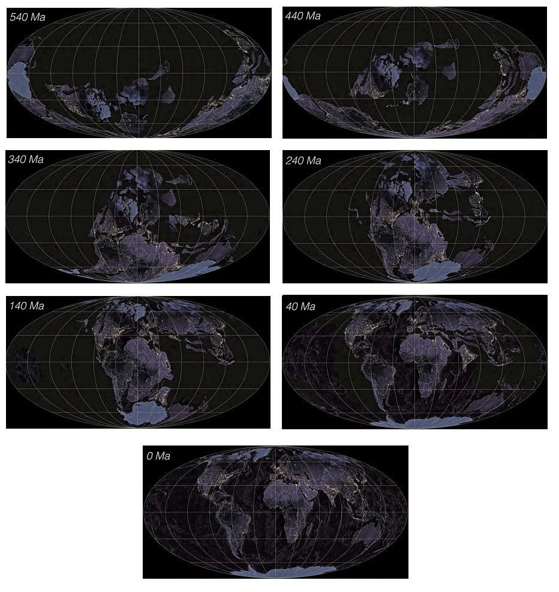

Fig 1: World map showing the change in continental configuration along latitude from Palaeozoic to Present day (540-0 my) in  100my interval.

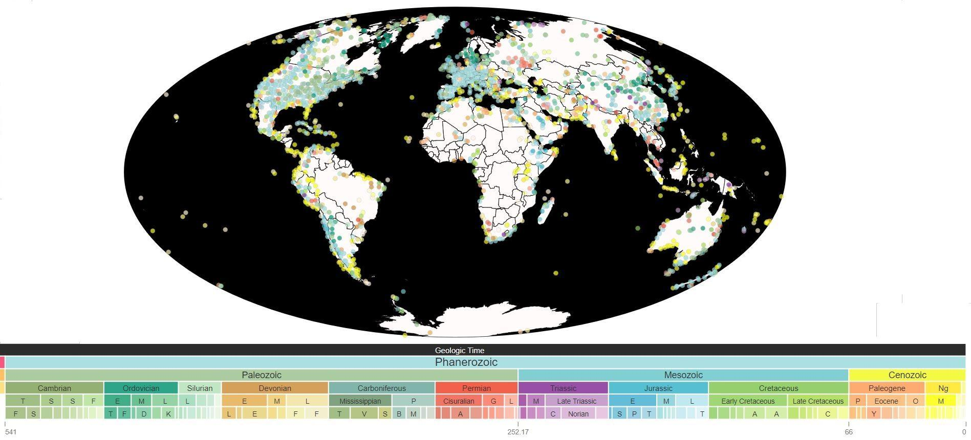Fig 2: Map showing the global distribution of Gastropod group from Palaeozoic to recent. The coloured circles are representing the location of the fossil occurrence according to geologic time.

**Materials and Methods:**

Benthic molluscs (class: Gastropoda) from Palaeozoic to recent are used in this study to estimate their origination and extinction rates. We divided the whole period into 50 (approx. 11my each) equally divided time bins (Alroy et al, 2008) and calculated the rate of origination and extinction. Our database contains 1,11,500 fossil occurrences representing 4526 unique genera belonging to 426 families.

Data on first appearance (FAD) along with their respective paleolatitude and last appearance (LAD) along with their respective latitude for all the species were collected from the Paleobiology Database by downloading ‘occurrence of specimens’ for 540my to recent (http://fossilworks.org/; date: 13 June 2020). For the calculation of origination and extinction rates, we documented the minimum value of  FAD and maximum value of LAD for each genus and family to calculated their total range of expansion and estimated per capita origination and extinction rate for each bin using the following formulae proposed by Foote, 2000.

Per capita origination rate = -ln(Nbt/Nt) / (t)

Where

Nbt - Number of taxa that make their first appearance before the interval and their last appearance afterwards

Nt - Number of taxa at the beginning of the interval

t= Time interval

per capita extinction rate = -ln(Nbt/Nb) / (t)

Where,

Nbt - Number of taxa that make their first appearance before the interval and their last appearance afterwards.

Nb - Number of taxa at the end of the interval.

t= Time interval

         All the analysis were performed for both family and genus level using R software (R Core Team, 2012). All the data handling procedures are discussed in detail in the supplementary section (Data file S1A-D) along with their R codes (Data file S2).

**Result and Discussion:**

Our data show a significant variation in the number of families between tropics (0°- 23°), extratropics (23°- 60°)and polar (60°- 90°) regions for both origination and extinction (Fig 3). Similar variation is found for genus-level data (Fig S1).

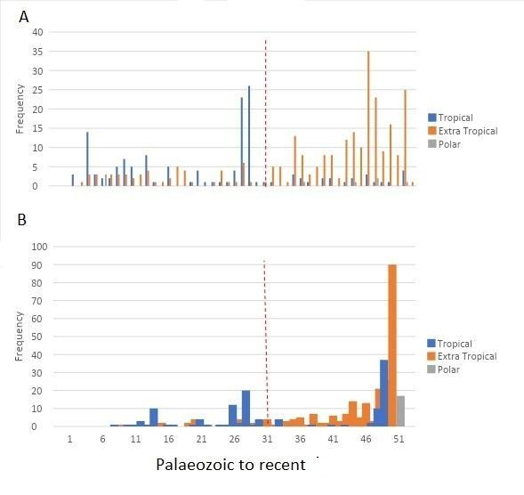

Fig 3: Barplots showing per interval variation in number of marine gastropod families originated (A) and extinct (B) in tropics, extratropics and polar regions over Palaeozoic to recent. Data are binned into 50 intervals averaging 11my in duration.

In overall data, the total number of families originated in tropics is higher than extratropics and pole before Triassic-Jurassic (T-Jr) mass extinction event (i.e. time bin 1-30). But, after Triassic-Jurassic extinction (i.e. time bin 31-50) we observed an opposite pattern i. e. originated taxa are more in extratropics than tropical and polar regions  (Fig4A). Same trend was found for extinct families (Fig4B). We also established this pattern for genus-level data (Fig S2).

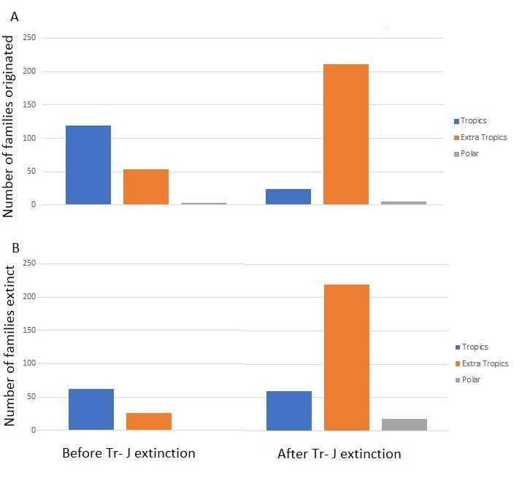

Fig 4: Barplots showing overall variation in number of families before and after Triassic-Jurassic extinction in tropics, extratropics and polar region for origination (A) and extinction (B).

The distribution of origination and extinction rates shows large fluctuation over time. Significant increase in extinction rates is coinciding with the Big Five mass extinction event followed by an increase in the rate of origination (Fig 5A & S3A). Variation of origination rate shows a similar pattern with the number of family distribution in tropics and extratropical region i.e. a shift of higher origination rate in extratropics than tropics after T- Jr extinction. Same is true for extinction rate (Fig 5B-C, S3B-C).

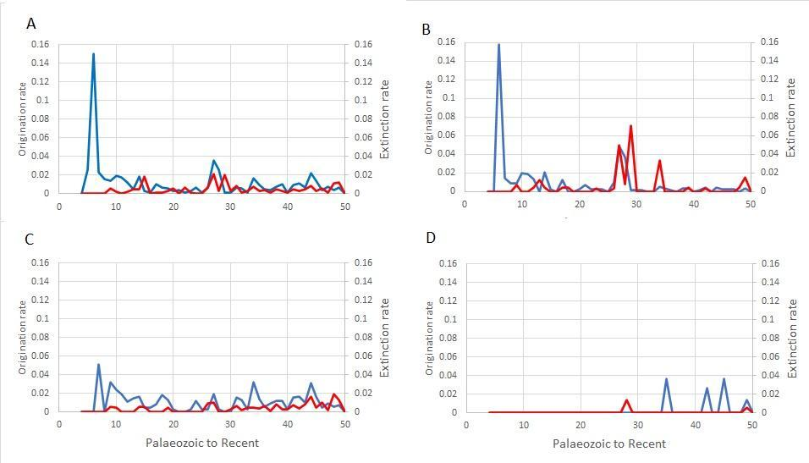

Fig 5: Plots showing per capita origination rates (blue lines) and extinction rates (red lines) for overall (A), tropical(B), extratropical(C) and Polar (D) families.

From all the above observations, we can conclude that overall data shows a large variation in origination and extinction rate with latitude. Our preliminary analysis indicates that the origination and extinction rate was higher in tropics before T- Jr mass extinction, but after T- Jr mass extinction event, both origination and extinction rate became higher in extratropics than tropical region. This observation contradicts Jablonski’s OTT model. One of the reason for T- Jr mass extinction event is the formation ‘Pangea’ (Erwin, 1994; Yugan et al, 1994). Formation of the supercontinent brings a lot of changes in both biotic and abiotic conditions (Olden, 2006; Alroy et al, 2008; Shi & Waterhouse, 2010; Zubin-Stathopoulos et al, 2013), which can substantially decrease the origination and extinction rate of gastropod group globally. Therefore, to decipher the effect of Pangea formation on origination and extinction rates of gastropod group, require detail information about the environmental and ecological parameters and how they changed over time. These parameters will also help us for a better understanding of the OTT model.

**References:**

Alroy, J. (2008). Dynamics of origination and extinction in the marine fossil record. Proceedings of the National Academy of Sciences, 105(Supplement 1), 11536-11542.

Alroy, J., Aberhan, M., Bottjer, D. J., Foote, M., Fürsich, F. T., Harries, P. J., ... & Kosnik, M. A. (2008). Phanerozoic trends in the global diversity of marine invertebrates. *Science*, *321*(5885), 97-100.

Benton, M. J. (1995). Diversification and extinction in the history of life. Science, 268(5207), 52-58.

Benton, M. J. The Red Queen and the Court Jester: species diversity and the role of biotic and abiotic factors through time. Science 323, 728–732 (2009).

 Cecca, F., Vrielynck, B., Lavoyer, T., & Gaget, H. (2005). Changes in the ammonite taxonomical diversity gradient during the late Jurassic–early Cretaceous. Journal of Biogeography, 32(3), 535-547.

Chase, J. M., Abrams, P. A., Grover, J. P., Diehl, S., Chesson, P., Holt, R. D., ... & Case, T. J. (2002). The interaction between predation and competition: a review and synthesis. Ecology letters, 5(2), 302-315.

Cherns L, Wheeley JR and Wright VP (2011) Taphonomic bias in shelly faunas through time: early aragonitic dissolution and its implications for the fossil record. In Taphonomy: Allison P A and Bottjer D J (eds) Springer, Netherlands, pp. 79 – 105.

Crame, J. A. (2001). Taxonomic diversity gradients through geological time. Diversity and Distributions, 7(4), 175-189.

Currie, D. J. 1991. Energy and large-scale patterns of animal and plant species richness. American Naturalist 137:27–49.

Currie, D. J., G. G. Mittelbach, H. V. Cornell, R. Field, J.-F. Gue´gan, B. A. Hawkins, D. M. Kaufman, et al. 2004. Predictions and tests of climate-based hypotheses of broad-scale variation in taxonomic richness. Ecology Letters 7:1121–1134.

Erwin, D. H. (1994). The Permo–Triassic extinction. *Nature*, *367*(6460), 231-236.

Ezard, T. H. G., Aze, T., Pearson, P. N. & Purvis, A. Interplay between changing climate and species’ ecology drives macroevolutionary dynamics. Science 332, 349–351 (2011). 3. Benton, M. J. Exploring macroevolution

 F. Cecca, Palaeobiogeography of Marine Fossil Invertebrates—Concepts and Methods (Taylor and Francis, London, 2002).

Foote, M. (2000). Origination and extinction components of taxonomic diversity: general problems. *Paleobiology*, *26*(sp4), 74-102.

Giribet (2008) Bivalvia. In W. F. Ponder and D. R. Lindberg (Eds) Phylogeny and Evolution of the Mollusca, University of California Press, California, pp.105-141.

Gosz, J. R. (1992). Gradient analysis of ecological change in time and space: implications for forest management. Ecological Applications, 2(3), 248-261.

Hawkins, B. A., R. Field, H. V. Cornell, D. J. Currie, J.-F. Gue´gan, D. M. Kaufman, J. T. Kerr, et al. 2003. Energy, water and broadscale geographic patterns of species richness. Ecology 84:3105– 3117.

Hillebrand, H. (2004). On the generality of the latitudinal diversity gradient. The American Naturalist, 163(2), 192-211.

Hunter, J. P. (1998). Key innovations and the ecology of macroevolution. Trends in ecology & evolution, 13(1), 31-36.

Khan A, Manokaran S, Lyla S and Nazeer Z (2010) Biodiversity of epibenthic community in the inshore waters of southeast coast of India. Biologia, 65:704 – 713.

Lehtonen, S., Silvestro, D., Karger, D. N., Scotese, C., Tuomisto, H., Kessler, M., ... & Antonelli, A. (2017). Environmentally driven extinction and opportunistic origination explain fern diversification patterns. Scientific reports, 7(1), 1-12.

Leighton, L. R. (2005). The latitudinal diversity gradient through deep time: testing the “age of the tropics” hypothesis using Carboniferous productidine brachiopods. Evolutionary Ecology, 19(6), 563-581.

M. L. Rosenzweig, Species Diversity in Space and Time (Cambridge Univ. Press, Cambridge, 1995).

MacArthur RH (1969) Patterns of communities in the tropics. Biol J Linnean Soc 1:19–30. 11.

Mittelbach, G. G., C. F. Steiner, S. M. Scheiner, K. L. Gross, H. L. Reynolds, R. B. Waide, M. R. Willig, et al. 2001. What is the observed relationship between species richness and productivity? Ecology 82:2381–2396.

Mittelbach, G. G., C. F. Steiner, S. M. Scheiner, K. L. Gross, H. L. Reynolds, R. B. Waide, M. R. Willig, et al. 2001. What is the observed relationship between species richness and productivity? Ecology 82:2381–2396.

Mittelbach, G. G., Schemske, D. W., Cornell, H. V., Allen, A. P., Brown, J. M., Bush, M. B., ... & McCain, C. M. (2007). Evolution and the latitudinal diversity gradient: speciation, extinction and biogeography. *Ecology Letters*, *10*(4), 315-331.

Nardin, E., Goddéris, Y., Donnadieu, Y., Hir, G. L., Blakey, R. C., Pucéat, E., & Aretz, M. (2011). Modeling the early Paleozoic long-term climatic trend. Bulletin, 123(5-6), 1181-1192.

Olden, J. D. (2006). Biotic homogenization: a new research agenda for conservation biogeography. *Journal of Biogeography*, *33*(12), 2027-2039.

Parsons-Hubbard, K. M., Powell, E. N., Raymond, A., Walker, S. E., Brett, C., Ashton-Alcox, K., ... & Deline, B. (2008). The taphonomic signature of a brine seep and the potential for Burgess Shale style preservation. Journal of Shellfish Research, 27(1), 227-239.

R Core Development Team. 2012. R: a language and environment for statistical computing. R Foundation for Statistical Computing, Vienna www.R-project.org. June 2014.

Rosenzweig ML (1975) in Ecology and Evolution of Communities, eds Cody ML, Diamond JM (Belknap, Cambridge, MA), pp 121–140. 12.

Scotese, C. R. (2004). A continental drift flipbook. The Journal of Geology, 112(6), 729-741.

Sepkoski Jr, J. J. (1978). A kinetic model of Phanerozoic taxonomic diversity I. Analysis of marine orders. Paleobiology, 223-251.

Sepkoski Jr., in Global Events and Event Stratigraphy. 0. H. Walliser, Ed. (Springer, Berlin, 1996), pp. 35-52.

Sepkoski, J. J., Bambach, R. K., Raup, D. M., & Valentine, J. W. (1981). Phanerozoic marine diversity and the fossil record. Nature, 293(5832), 435-437.

Shen, S. Z., & Shi, G. R. (2004). Capitanian (Late Guadalupian, Permian) global brachiopod palaeobiogeography and latitudinal diversity pattern. Palaeogeography, Palaeoclimatology, Palaeoecology, 208(3-4), 235-262.

Shi, G. R., & Waterhouse, J. B. (2010). Late Palaeozoic global changes affecting high-latitude environments and biotas: an introduction. Palaeogeography, Palaeoclimatology, Palaeoecology, 298(1-2), 1-16.

Signor, P. W. (1990). The geologic history of diversity. Annual Review of Ecology and Systematics, 21(1), 509-539.

Soininen, J. (2010). Species turnover along abiotic and biotic gradients: patterns in space equal patterns in time?. BioScience, 60(6), 433-439.

Stigall, A. L., Edwards, C. T., Freeman, R. L., & Rasmussen, C. M. (2019). Coordinated biotic and abiotic change during the Great Ordovician Biodiversification Event: Darriwilian assembly of early Paleozoic building blocks. Palaeogeography, Palaeoclimatology, Palaeoecology, 530, 249-270.

Tittensor, D. P., Mora, C., Jetz, W., Lotze, H. K., Ricard, D., Berghe, E. V., & Worm, B. (2010). Global patterns and predictors of marine biodiversity across taxa. Nature, 466(7310), 1098-1101.

Valentine, J. W. (1969). Patterns of taxonomic and ecological structure of the shelf benthos during Phanerozoic time. *Palaeontology*, *12*(4), 684-709.

Walker TD, Valentine JW (1984) Equilibrium models of evolutionary species diversity and the number of empty niches. Am Nat 124:887–899.

Walker, S. E., & Goldstein, S. T. (1999). Taphonomic tiering: experimental field taphonomy of molluscs and foraminifera above and below the sediment-water interface. Palaeogeography, Palaeoclimatology, Palaeoecology, 149(1-4), 227-244.

Yugan, J., Jing, Z., & Qinghua, S. (1994). Two phases of the end-Permian mass extinction.

Zubin-Stathopoulos, K. D., Beauchamp, B., Davydov, V. I., & Henderson, C. M. (2013). Variability of Pennsylvanian–Permian carbonate associations and implications for NW Pangea Palaeogeography, east-central British Columbia, Canada. *Geological Society, London, Special Publications*, *376*(1), 47-72.

**Supplementary materials:**

Fig S1- S3

Data handling procedure S1A- D

R codes S2

Fig S1: Barplot showing per interval variation in number of marine gastropod genus originated (A) and extinct (B) in tropics, extratropics and polar regions over Palaeozoic to recent. Data are binned into 50 intervals averaging 11my in duration.

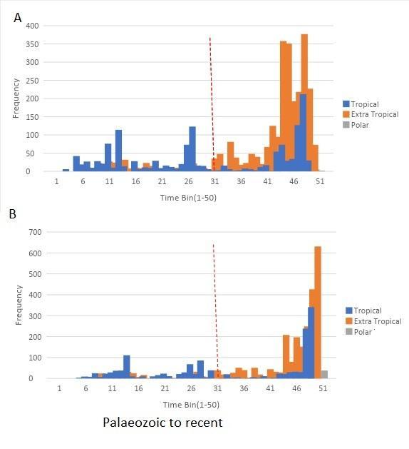

Fig S2: Barplot showing overall variation in number of genera before and after Triassic-Jurassic extinction in tropics, extratropics and polar region for origination (A) and extinction (B).

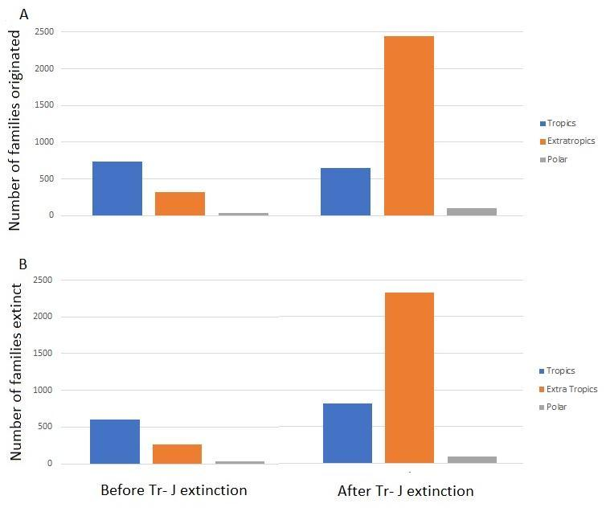

Fig S3: Plots showing per capita origination rates (blue lines) and extinction rates (red lines) for overall (A), tropical(B), extratropical(C) and Polar (D) genera.

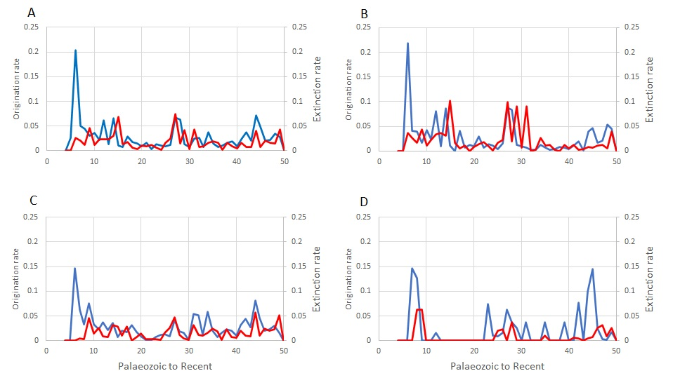

**Data File S1: Data handling procedure**

**A: Data Handling procedure for FAD**

1. We first select the Family, Max Ma, Paleo Latitude column and past in a separate excel file. Then we sort the data in the following way first by Family (A-Z), then by Max Ma (Largest to smallest), then by Paleolatitude (largest to smallest) using custom sort in excel.
2. We then divide the Paleo Latitude Column into LatBin Column by using filter mode and choosing the range between with appropriate range as specified and then manually filling the LatBin Column once filtered the Column of Paleolatitude.
3. We then divide the Max Ma Column into TimeBin Column by using filter mode and choosing the range between with appropriate range as specified and then manually filling the TimeBin Column once filtered the Column of Max Ma.
4. Now, we delete duplicates by the function delete duplicate by selecting only the first column as the entity for deleting the duplicates of duplicate family names.
5. Now in a separate excel file  we place the Time Bin 1-50 and then fill TNH, TSH, ETNH, ETSH, PNH, PSH with the count data by choosing the filter of Time Bin and then filter it again with the corresponding Lat Bin.
6. After that we sum each of TNH -TSH, ETNH – ETSH, PNH-PSH pair and store in a particular column as TT, ETT, PT.
7. Then, we Calculate the ratio TT/(TT+ETT+PT) and ETT/(TT+ETT+PT) and similarly for TNH and TSH, ETNH, ETSH.
8. We then plot graphs between the Time Bin and TT – ETT and similarly for all others and Compare the results accordingly.

**B: Data Handling procedure for LAD**

1. We first select the Family, Min Ma, Paleo Latitude column and past in a separate excel file. Then we sort the data in the following way first by Family (A-Z), then by Min Ma (Smallest to Largest), then by Paleolatitude (largest to smallest) using custom sort in excel.
2. Rest the procedure is the same as stated above in FAD.

**C: Origination Rate Calculation Method**

1. We first Select the Family Column , min ma (LAD) , max ma (FAD) and in a  separate excel sheet and then count the number of families for all the distinct range FAD - LAD and sort the data according to FAD.
2. In a separate excel sheet we store the count of families starting with a particular FAD time bin. Then from the above count data we subtract the range that has the same FAD and LAD. After this we name the column as Nft .
3. We take the Cumulative sum of the count data and store in a different column ,then we shift the entire column of cumulative sum by one row. After that delete the last data of cumulative sum.
4. Now using the excel sheet where we stored the family ,FAD and LAD count we filter out in the following way : for a particular time bin suppose 5 we select the the LAD from 1 to 5 and then subtract this data from the cumulative sum for that particular bin 5.
5. After this we add the one that has the same FAD and LAD for a particular time bin and name this column as Nbt.
6. Also, we add the column Nft and Nbt and name it as Nt . After that using the formula we compute: **per capita origination rate = -ln(Nbt/Nt) / (t) where t is time bin.**

**D: Extinction Rate Calculation Method**

1. We first Select the Family Column , min ma (LAD) , max ma (FAD) and in a  separate excel sheet and then count the number of families for all the distinct range FAD - LAD and sort the data according to FAD.
2. In a separate excel sheet we store the count of the number of families starting with a particular LAD time bin. Then from the above count data we subtract the range that has the same FAD and LAD. After this we name the column as Nbl .
3. We Copy the Nbt data from the origination rate excel file.
4. Now, we add the column Nbl and Nbt and name it as Nb . After that using the formula we compute: **per capita extinction rate = -ln(Nbt/Nb) / (t) where t is time bin.**

**Data File S2: R CODE**

dataset<- read_xlsx('Dummy.xlsx')

# for PaleoLatBin division based on the criteria

for (i in 1:dim(dataset)[1])

{

   if(dataset$paleolat[i]>=-90 &&  dataset$paleolat[i]<=-60.01)

  {

     dataset$LatBin[i] = 1

  }

  else if(dataset$paleolat[i]>=-60 &&  dataset$paleolat[i]<=-23.01)

  {

    dataset$LatBin[i] = 2

  }

  else if(dataset$paleolat[i]>=-23 &&  dataset$paleolat[i]<=0)

  {

    dataset$LatBin[i] = 3

  }

  else if(dataset$paleolat[i]>=0.01 &&  dataset$paleolat[i]<=23)

  {

    dataset$LatBin[i] = 4

  }

  else if(dataset$paleolat[i]>=23.01 &&  dataset$paleolat[i]<=60)

  {

    dataset$LatBin[i] = 5

  }

  else if(dataset$paleolat[i]>=60.01 &&  dataset$paleolat[i]<=90)

  {

    dataset$LatBin[i] = 6

  }

  else

  {

    dataset$LatBin[i] = " "

  }

}

# for time Bin division based on the criteria

for (i in 1:dim(dataset)[1])

{

  if(dataset$min_ma[i]>=530 && dataset$min_ma[i]<=541)

    dataset$TimeBin[i] = 1

else if(dataset$min_ma[i]>=519 && dataset$min_ma[i]<=529.9)

  dataset$TimeBin[i] = 2

else if(dataset$min_ma[i]>=508 && dataset$min_ma[i]<=518.9)

  dataset$TimeBin[i] = 3

else if(dataset$min_ma[i]>=497 && dataset$min_ma[i]<=507.9)

  dataset$TimeBin[i] = 4

else if(dataset$min_ma[i]>=486 && dataset$min_ma[i]<=496.9)

  dataset$TimeBin[i] = 5

else if(dataset$min_ma[i]>=475 && dataset$min_ma[i]<=485.9)

  dataset$TimeBin[i] = 6

else if(dataset$min_ma[i]>=464 && dataset$min_ma[i]<=474.9)

  dataset$TimeBin[i] = 7

else if(dataset$min_ma[i]>=453 && dataset$min_ma[i]<=463.9)

  dataset$TimeBin[i] = 8

else if(dataset$min_ma[i]>=442 && dataset$min_ma[i]<=452.9)

  dataset$TimeBin[i] = 9

else if(dataset$min_ma[i]>=431 && dataset$min_ma[i]<=441.9)

  dataset$TimeBin[i] = 10

else if(dataset$min_ma[i]>=420 && dataset$min_ma[i]<=430.9)

  dataset$TimeBin[i] = 11

else if(dataset$min_ma[i]>=409 && dataset$min_ma[i]<=419.9)

  dataset$TimeBin[i] = 12

else if(dataset$min_ma[i]>=398 && dataset$min_ma[i]<=408.9)

  dataset$TimeBin[i] = 13

else if(dataset$min_ma[i]>=387 && dataset$min_ma[i]<=397.9)

  dataset$TimeBin[i] = 14

else if(dataset$min_ma[i]>=376 && dataset$min_ma[i]<=386.9)

  dataset$TimeBin[i] = 15

else if(dataset$min_ma[i]>=365 && dataset$min_ma[i]<=375.9)

  dataset$TimeBin[i] = 16

else if(dataset$min_ma[i]>=354 && dataset$min_ma[i]<=364.9)

  dataset$TimeBin[i] = 17

else if(dataset$min_ma[i]>=343 && dataset$min_ma[i]<=353.9)

  dataset$TimeBin[i] = 18

else if(dataset$min_ma[i]>=332 && dataset$min_ma[i]<=342.9)

  dataset$TimeBin[i] = 19

else if(dataset$min_ma[i]>=321 && dataset$min_ma[i]<=331.9)

  dataset$TimeBin[i] = 20

else if(dataset$min_ma[i]>=310 && dataset$min_ma[i]<=320.9)

  dataset$TimeBin[i] = 21

else if(dataset$min_ma[i]>=299 && dataset$min_ma[i]<=309.9)

  dataset$TimeBin[i] = 22

else if(dataset$min_ma[i]>=288 && dataset$min_ma[i]<=298.9)

  dataset$TimeBin[i] = 23

else if(dataset$min_ma[i]>=277 && dataset$min_ma[i]<=287.9)

  dataset$TimeBin[i] = 24

else if(dataset$min_ma[i]>=266 && dataset$min_ma[i]<=276.9)

  dataset$TimeBin[i] = 25

else if(dataset$min_ma[i]>=255 && dataset$min_ma[i]<=265.9)

  dataset$TimeBin[i] = 26

else if(dataset$min_ma[i]>=244 && dataset$min_ma[i]<=254.9)

  dataset$TimeBin[i] = 27

else if(dataset$min_ma[i]>=233 && dataset$min_ma[i]<=243.9)

  dataset$TimeBin[i] = 28

else if(dataset$min_ma[i]>=222 && dataset$min_ma[i]<=232.9)

  dataset$TimeBin[i] = 29

else if(dataset$min_ma[i]>=211 && dataset$min_ma[i]<=221.9)

  dataset$TimeBin[i] = 30

else if(dataset$min_ma[i]>=200 && dataset$min_ma[i]<=210.9)

  dataset$TimeBin[i] = 31

else if(dataset$min_ma[i]>=189 && dataset$min_ma[i]<=199.9)

  dataset$TimeBin[i] = 32

else if(dataset$min_ma[i]>=178 && dataset$min_ma[i]<=188.9)

  dataset$TimeBin[i] = 33

else if(dataset$min_ma[i]>=167 && dataset$min_ma[i]<=177.9)

  dataset$TimeBin[i] = 34

else if(dataset$min_ma[i]>=156 && dataset$min_ma[i]<=166.9)

  dataset$TimeBin[i] = 35

else if(dataset$min_ma[i]>=145 && dataset$min_ma[i]<=155.9)

  dataset$TimeBin[i] = 36

else if(dataset$min_ma[i]>=134 && dataset$min_ma[i]<=144.9)

  dataset$TimeBin[i] = 37

else if(dataset$min_ma[i]>=123 && dataset$min_ma[i]<=133.9)

  dataset$TimeBin[i] = 38

else if(dataset$min_ma[i]>=112 && dataset$min_ma[i]<=122.9)

  dataset$TimeBin[i] = 39

else if(dataset$min_ma[i]>=101 && dataset$min_ma[i]<=111.9)

  dataset$TimeBin[i] = 40

else if(dataset$min_ma[i]>=90 && dataset$min_ma[i]<=100.9)

  dataset$TimeBin[i] = 41

else if(dataset$min_ma[i]>=79 && dataset$min_ma[i]<=89.9)

  dataset$TimeBin[i] = 42

else if(dataset$min_ma[i]>=68 && dataset$min_ma[i]<=78.9)

  dataset$TimeBin[i] = 43

else if(dataset$min_ma[i]>=57 && dataset$min_ma[i]<=67.9)

  dataset$TimeBin[i] = 44

else if(dataset$min_ma[i]>=46 && dataset$min_ma[i]<=56.9)

  dataset$TimeBin[i] = 45

else if(dataset$min_ma[i]>=35 && dataset$min_ma[i]<=45.9)

  dataset$TimeBin[i] = 46

else if(dataset$min_ma[i]>=24 && dataset$min_ma[i]<=34.9)

  dataset$TimeBin[i] = 47

else if(dataset$min_ma[i]>=13 && dataset$min_ma[i]<=23.9)

  dataset$TimeBin[i] = 48

else if(dataset$min_ma[i]>=2 && dataset$min_ma[i]<=12.9)

  dataset$TimeBin[i] = 49

else if(dataset$min_ma[i]>=-9 && dataset$min_ma[i]<=1.9)

  dataset$TimeBin[i] = 50

}

# for counting the Timbin for each LatBin

count(dataset,TimeBin,LatBin)

list = dataset %>% count(TimeBin,LatBin)

# for Calcultion of Tropical Total , Extra Tropical Total and Polar Total

datacal<- read_xlsx('Dumm.xlsx')

datacal[,8]<- datacal[,2] + datacal[,3]

datacal[,9]<- datacal[,4] + datacal[,5]

datacal[,10]<- datacal[,6] + datacal[,7]

# for Calculating Ratio for Tropical Total / (TT+ETT+PT)

datacal[,11]<- datacal[,8]/(datacal[,8] + datacal[,9] + datacal[,10])

datacal[,12]<- datacal[,9]/(datacal[,8] + datacal[,9] + datacal[,10])

# for Plotting grap of TT vs Time bin and ETT vs Time bin

qplot(datacal$`Time bin`, datacal$`TT / (TT+ETT+PT)`) + geom_line()

qplot(datacal$`Time bin`, datacal$`ETT / (TT+ETT+PT)`) + geom_line()

**Calculation of Origination and Extinction rate Parameter:**

dataset<- read_xlsx('Family_gastropod.xlsx')

# for calculatig the NFT Value

count(dataset,dataset$`Time Bin_FAD`)

list_NFT = dataset %>% count(dataset$`Time Bin_FAD`)

# for calculatig the NBL Value

count(dataset,dataset$`Time Bin_LAD`)

list_NBL = dataset %>% count(dataset$`Time Bin_LAD`)

count(dataset,dataset$`Time Bin_LAD`,dataset$`Time Bin_FAD`)

list_pair = dataset %>% count(dataset$`Time Bin_LAD`,dataset$`Time Bin_FAD`)

names(list_pair)[names(list_pair) == "dataset$`Time Bin_FAD`"] <- "Time Bin_FAD"

names(list_pair)[names(list_pair) == "dataset$`Time Bin_LAD`"] <- "Time Bin_LAD"

names(list_pair)[names(list_pair) == "n"] <- "count"

list_pair$NFL <- list_pair$count

list_pair$generated_uid <- 1:nrow(list_pair)

list_pair <- list_pair[,c(5,1,2,3,4)]

for(i in 1:dim(list_pair)[1])

{

list_pair$NFL[i] = 0;

}

for (i in 1:dim(list_pair)[1])

{

if(list_pair$`Time Bin_LAD`[i] == list_pair$`Time Bin_FAD`[i])

{

list_pair$NFL[i] = list_pair$count[i];

}

else if (list_pair$`Time Bin_LAD`[i] != list_pair$`Time Bin_FAD`[i])

{

list_pair$NFL[i] = 0;

}

}

list_pair <- list_pair[order(list_pair$`Time Bin_LAD`, -list_pair$`Time Bin_FAD`),]

list_pair <- list_pair[!duplicated(list_pair$`Time Bin_LAD`), ]

list_NBL$n <- list_NBL$n -list_pair$NFL

# for calculating the list of Time Bin_FAD - Time Bin_LAD and Family

count(dataset,dataset$`Time Bin_FAD`,dataset$`Time Bin_LAD`)

list_NFLL = dataset %>% count(dataset$`Time Bin_FAD`,dataset$`Time Bin_LAD`)

write_xlsx(list_NFLL,"C:\\Users\\Rishabh\\Desktop\\Family R Code\\nfll.xlsx")

# for Calculatig the NFL Value

nfll<- read_xlsx('nfll.xlsx')

names(nfll)[names(nfll) == "dataset$`Time Bin_FAD`"] <- "Time Bin_FAD"

names(nfll)[names(nfll) == "dataset$`Time Bin_LAD`"] <- "Time Bin_LAD"

names(nfll)[names(nfll) == "n"] <- "count"

nfll$NBT <- nfll$count

for(i in 1:dim(nfll)[1])

{

nfll$NBT[i] = 0;

}

nfll$generated_uid <- 1:nrow(nfll)

nfll <- nfll[,c(5,1,2,3,4)]

nfll$NFL <- nfll$count

for(i in 1:dim(nfll)[1])

{

nfll$NFL[i] = 0;

}

for (i in 1:dim(nfll)[1])

{

if(nfll$`Time Bin_FAD`[i] == nfll$`Time Bin_LAD`[i])

{

nfll$NFL[i] = nfll$count[i];

}

else if (nfll$`Time Bin_FAD`[i] != nfll$`Time Bin_LAD`[i])

{

nfll$NFL[i] = 0;

}

}

# for Calculating the NBT

for (i in 3:dim(nfll)[1])

{

h=i-1;

for(j in 1:h)

{

if(nfll$`Time Bin_FAD`[j] < nfll$`Time Bin_FAD`[i] && nfll$`Time Bin_LAD`[j] > nfll$`Time Bin_FAD`[i])

{

nfll$NBT[i] <- nfll$NBT[i] + nfll$count[j];

}

}

h=0;

}

names(list_NFT)[names(list_NFT) == "n"] <- "NFT"

NFT_NBT_NFL_data <- nfll[!duplicated(nfll$`Time Bin_FAD`), ]

NFT_NBT_NFL_data$NFT <- list_NFT$NFT

df <- NFT_NBT_NFL_data[ -c(1,3:4) ]

df$NFT <- df$NFT-df$NFL